CISC-250

Lab 1 Solutions

Part I - Getting Started

1. List the different protocols that appear in the protocol column in the unfiltered

packet-listing window in step 7 above.

The protocols are listed in the *Protocol* column in the packet view. The various protocols

that can be seen are TCP, HTTP, DNS, SSL etc.

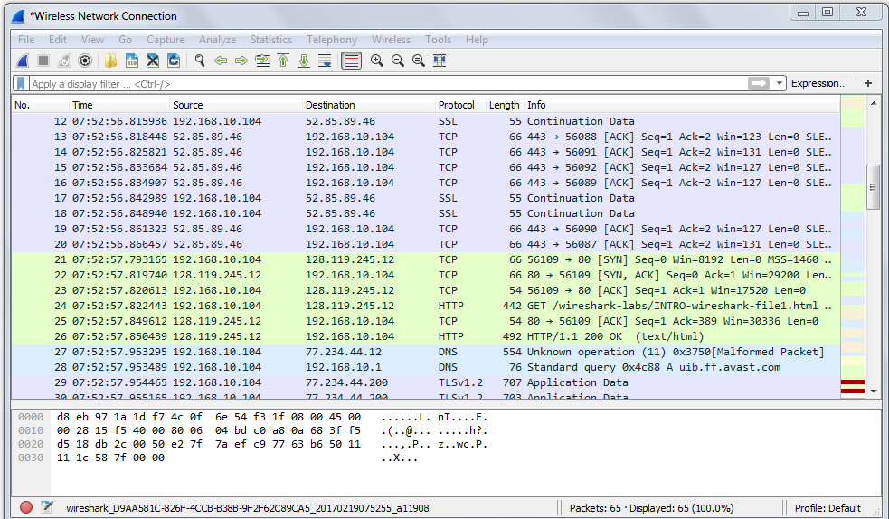

2. How long did it take from when the HTTP GET message was sent until the HTTP OK reply was received?

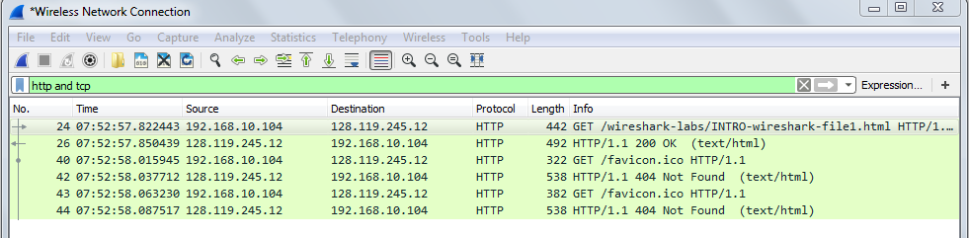

Taking the difference of the times between sending the GET message and receiving the OK message, we get the delay as 0.027996.

3. What is the Internet address of the gaia.cs.umass.edu? What is the Internet address of your computer?

The IP address for both Source and Destination is listed under Source and Destination Column

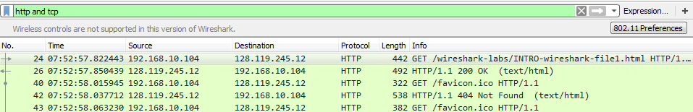

My computer has the IP address 192.168.10.104

gaia.cs.umass.edu has IP address 128.119.245.12

Your computer’s IP address may change depending on which network you are connecting to. For example, in the Windows version, I am connecting to my own Wi-Fi network, therefore it shows an IP address of a local network.

Part II - HTTP

1. The Basic HTTP GET/response interaction

Looking at the GET packet,

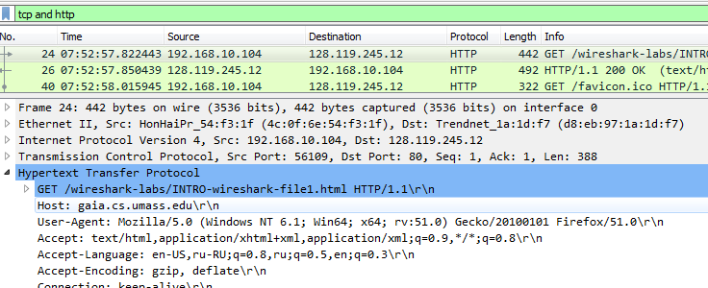

1. Is your browser running HTTP version 1.0 or 1.1? What version of HTTP is the server running?

Both are running HTTP 1.1

2. What languages (if any) does your browser indicate that it can accept to the server? English-US, Russian-RU

3. What is the IP address of your computer?

Analyzing the following GET message from my computer to gaia.cs.umass.edu,

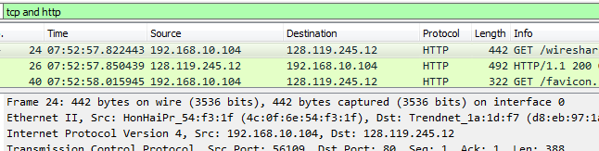

We see that,

My computer has the IP address 192.168.10.104

gaia.cs.umass.edu has IP address 128.119.245.12

4. What is the status code returned from the server to your browser?

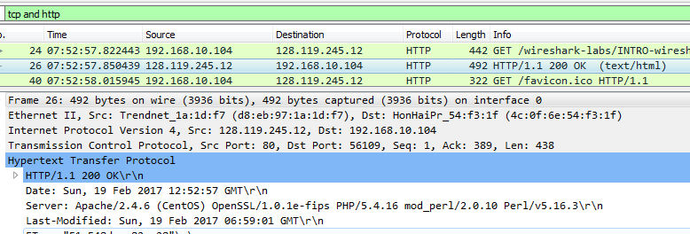

The code returned was 200, which means OK.

5. When the HTML file that you are retrieving was last modified at the server? When was it returned to your browser?

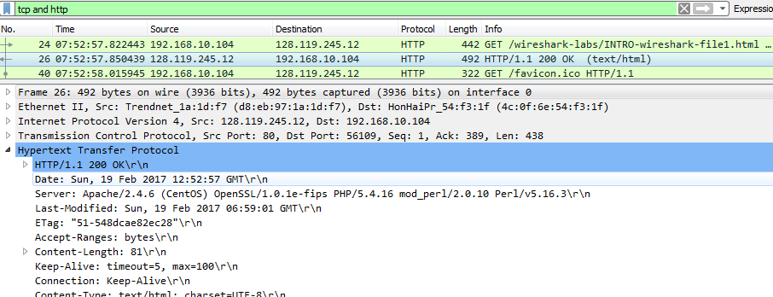

The time and date may vary depending on when you capture the packet, for mine, the document I just retrieved was last modified at 06:59:01 GMT on February 19, 2017 and returned to my browser at 07:52:57.

6. How many bytes of content are being returned to your browser?

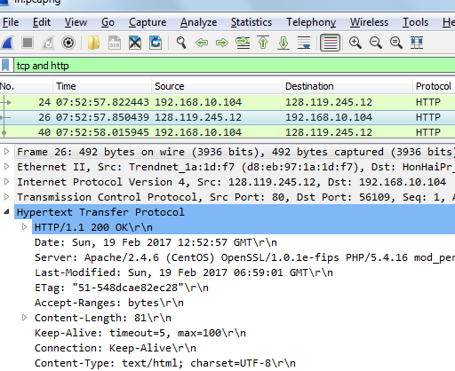

81 bytes

2. HTML Documents with Embedded Objects

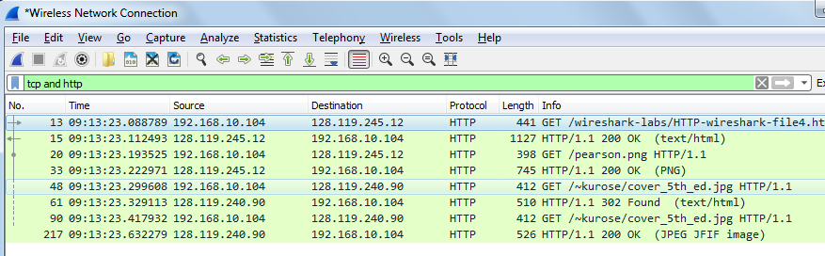

1. How many HTTP GET request messages were sent by your browser? **4 (one of the request message was for retrieving the /~kurose/cover-5th-ed.jpg image. However, this image was moved to a different URL so the first request got a 302 Found response message to tell the client the new location of the image, and the client sent another request to the new URL and finally got the 200 OK response message)**

2. To which Internet addresses were these GET requests sent?

For Windows, you can see these destination IP address directly from the Destination Column

For Macbook, you can find the IP address under Internet Protocol section



As you can see from the above screenshot there were 4 HTTP GET requests sent to the following Internet addresses:

a. 128.119.245.12

b. 128.119.245.12

c. 128.119.240.90

d. 128.119.240.90

3. How many HTTP response messages were received by your browser?

The browser received 4 response messages.

Part III – HTTP Message to TCP Segments

1. How many HTTP GET request messages were sent by your browser?

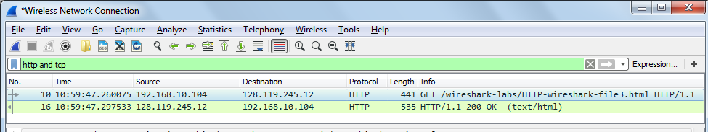

**1 GET request message was sent.**

2. How many data-containing TCP segments were needed to carry the single HTTP response?

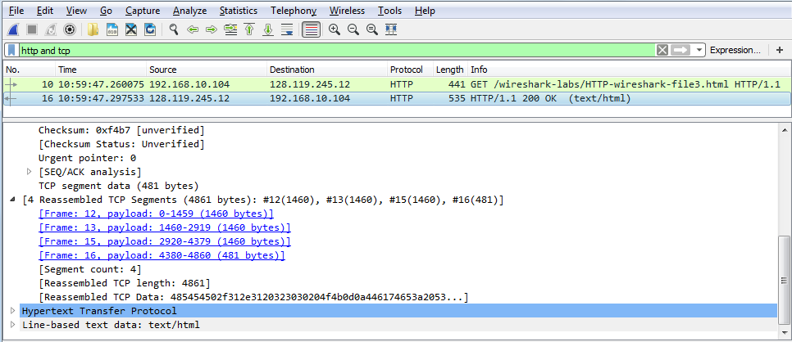

4 **TCP segment was required.**

3. What is the length of each of these TCP segments? 1460, 1460,1460, 481 (bytes)

4. What is the status code and phrase associated with the response to the HTTP GET request?

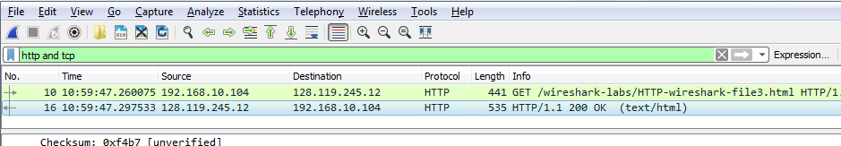

**200 OK**

5. What is the IP address and port number used by gaia.cs.umass.edu to send the file?

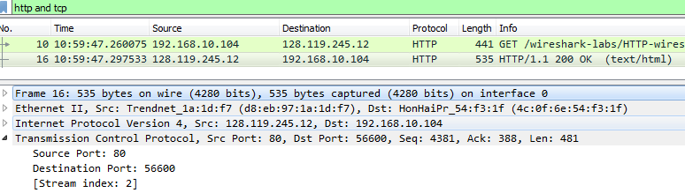

**For gaia.cs.umass.edu:**

IP address: 128.119.245.12

Port number: 80

What is the IP address and TCP port number used by your client computer (source) to receive the file?

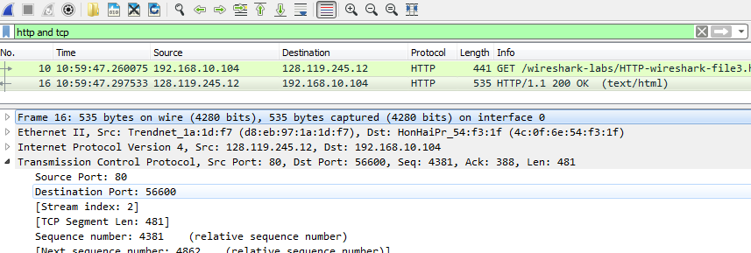

**For client computer:**

IP address: 192.168.10.104

Port number: 56600

These address and port number will vary depending on what network you connect to.

6. What are the sequence number and ACK number of the TCP segment containing the HTTP GET command?

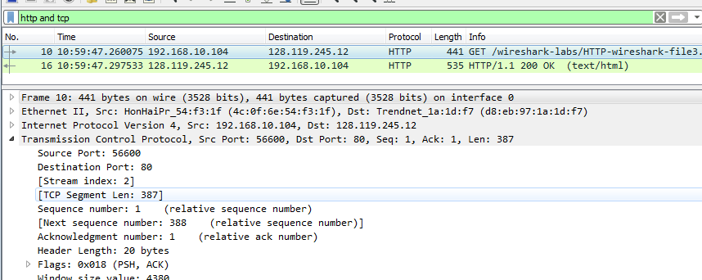

**Sequence No. = 1; ACK No. = 1**

**Please note that these are relative sequence numbers.**

The Next Step

1. Inspect the contents of the first HTTP GET request from your browser to the server. Do you see an “IF-MODIFIED-SINCE” line in the HTTP GET?

First GET Message

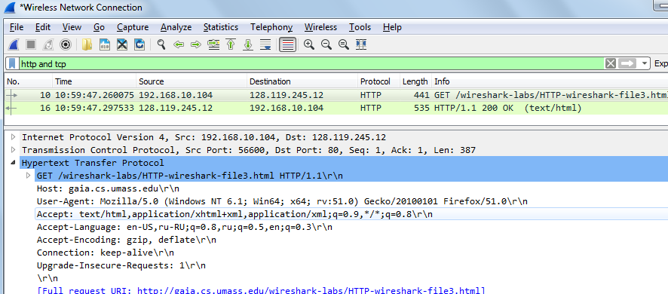

No.

2. Inspect the contents of the server response. Did the server explicitly return the contents of the file? How can you tell?

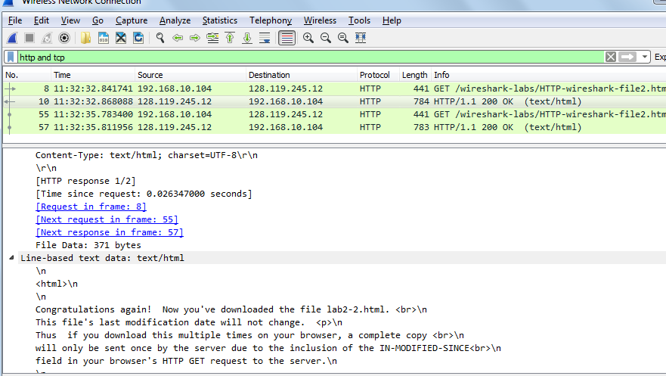

We see that the server has replied with the contents of the file.

3. Now inspect the contents of the second HTTP GET request from your browser to the server. Do you see an “IF-MODIFIED-SINCE:” line in the HTTP GET? If so, what information follows the “IF-MODIFIED-SINCE:” header?

Yes.

Please see the following:

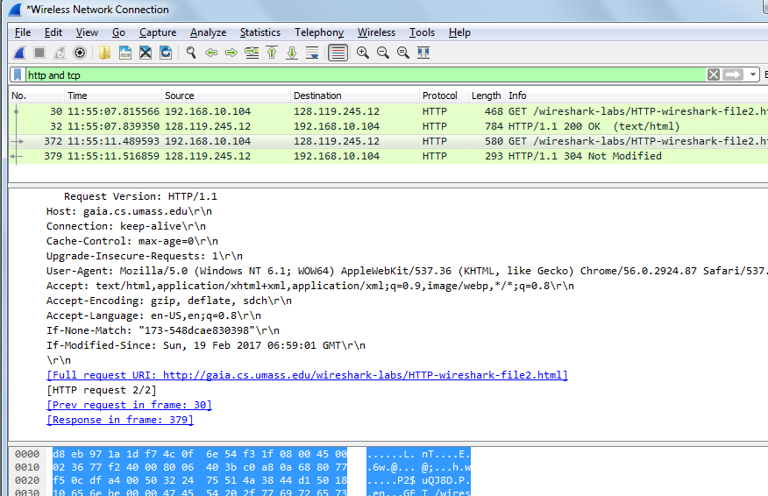

There is an if-modified-since in the second GET message. The information following it is the known file update that my computer is aware of.

4. What is the HTTP status code and phrase returned from the server in response to this second HTTP GET? Did the server explicitly return the contents of the file? Explain.

Response to second GET

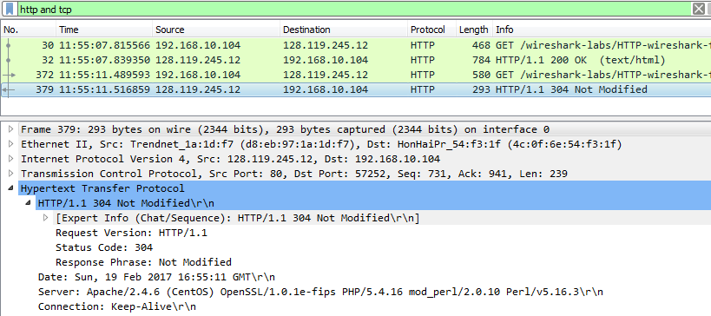

The response to the second GET has a 304 code meaning that the file was not modified since my computer last saw it. Hence the server has not explicitly returned the contents of the file.